(Insert parish and shop / outlet name)

COVIDSAFE MANAGEMENT PLAN

Stage 1

Date | 20 May 2020 | Version | 1
Next Review Date: | 20 June 2020
CovidSafe Plan Undertaken By: | (insert names here)
Responsibility: | (insert name of Rector / CIC / Equivalent)

CONTEXT
Context | (Parish to provide – detail an overview of the shop / outlet eg:  - Location  - Size  - Number of workers (volunteers)  - Opening hours  - Supervision arrangements)
Scope | This CovidSafe management plan is based on the Australian Government 3 step Framework for a CovidSafe Australia and includes the following essential requirements:  - Ensure gathering are no larger than 10 people  - Maintain 1.5M distancing and good hygiene and respiratory protocols  - Stay home if unwell  - Frequently clean and disinfect communal areas  - Implementation of this Covid Safe Plan
WHS Policy Statement | (Insert Parish Name/Ministry Unit) is committed to a healthy and safe workplace. We aim to remove or reduce and manage risks to the health, safety and wellbeing of all workers (clergy, employees, volunteers, and contractors), visitors, and anybody else who may be affected by our ministry activities, and also to ensure all work activities are undertaken in a safe manner.

COVIDSAFE PLAN
Critical control point | Support material | Further information or support material
Stay at Home if Unwell Policy  Workers and visitors are asked not to visit our shop / outlet if they have any cold or flu-like symptoms, have been overseas in the last 14 days or have been in contact with anyone showing signs of Coronavirus eg. fever, dry cough and sore throat  If the worker has cold or flu like symptoms, they should seek medical advice and get tested for COVID-19. A worker should get tested even if symptoms are mild. |  | Good hygiene for coronavirus (COVID 19)  https://www.health.gov.au/news/health-alerts/novel-coronavirus-2019-ncov-health-alert/how-to-protect-yourself-and-others-from-coronavirus-covid-19/good-hygiene-for-coronavirus-covid-19
Good Hygiene for Workers  All workers are inducted into our ‘good hygiene’ protocols. This means:  - We wash our hands often with soap and water. This includes before and after eating and after going to the toilet  - We use alcohol-based hand sanitisers when you cannot use soap and water  - We avoid touching your eyes, nose and mouth  - We clean and disinfect surfaces we use often such as benchtops, desks and doorknobs  - We clean and disinfect objects we use often such as mobile phones, keys, wallets etc  - We use tap and go instead of cash where possible  - We try to increase the amount of fresh air by opening windows or changing air conditioning  - We ensure bathrooms are well stocked with hand wash and paper towel. |  | How to handwash poster:  https://www.who.int/gpsc/5may/How_To_HandWash_Poster.pdf?ua=1  How to hand rub poster:  https://www.who.int/gpsc/5may/How_To_HandRub_Poster.pdf  Simple steps to help stop the spread poster:
 |  | https://www.health.gov.au/sites/default/files/documents/2020/03/coronavirus-covid-19-print-ads-simple-steps-to-stop-the-spread-coronavirus-covid-19-print-ads-simple-steps-to-stop-the-spread.pdf
Good Hygiene for Customers  - We ask all visitors to use hand sanitiser before entering our shop / outlet  - We have installed signage reminding everyone of these requirements and obligations for good general health | Wellness poster
Social Distancing  Social distancing is one of the best things we can do to stop the spread of coronavirus. Whenever and wherever we can, this protocol will be applied, including:  - Placement of social distancing markers on the floor in areas where customers line up or where workers perform tasks.  - Responsible person on floor to monitor and ensure everyone is keeping the required distance from each other  - Service counters set up to support social distancing requirements | Social distancing poster | Keeping your distance poster:  https://www.health.gov.au/sites/default/files/documents/2020/03/coronavirus-covid-19-keeping-your-distance.pdf  Physical distancing checklist:  https://www.safeworkaustralia.gov.au/sites/default/files/2020-04/COVID-19-Physical-Distancing-Checklist.pdf
Cleaning  We recognise that cleaning is an essential part of disinfection because dirt and grime can inactivate many disinfectants. Cleaning reduces the amount of dirt and so allows disinfectant to work. Removal of germs such as the virus that causes COVID-19 requires thorough cleaning followed by disinfection.  As such, our outlet has developed a cleaning program that has taken into consideration touch point locations and other cleaning needs. | Routine environmental cleaning information  Cleaning plan | Retail cleaning:  https://www.safeworkaustralia.gov.au/covid-19-information-workplaces/cleaning-prevent-spread-covid-19  Cleaning checklist:  https://www.safeworkaustralia.gov.au/sites/default/files/2020-04/COVID-19_Cleaning-Checklist.pdf
Handling second-hand goods and infection control  According to the World Health Organisation, it is not certain how long the COVID-19 virus can survive on surfaces. Reports and studies are telling us that time can vary from a few hours to several days, depending on the type of surface.  In line with this, we take reasonable precautions by:  - wearing gloves when sorting all items  - only excepting items (clothing, manchester and soft furnishings) that are in good usable condition  - Cleaning children’s toys with a disinfectant solution  - Wiping down shoes, accessories, handbags, books and homewares with a disinfectant solution  - Washing our hands with soap and water or use an alcohol-based sanitiser after handling second-hand goods  - Avoiding touching our eyes, mouth and nose  We encourage our customers to also implement infection control procedures with all items that they purchase. At are counter areas we display information to promote this action. | CovidSafe cleaning information for your purchases | NSW Health COVID 19 – Frequently asked questions  https://www.health.nsw.gov.au/Infectious/covid-19/Pages/frequently-asked-questions.aspx

Customer entry and exit protocols
Social distancing consideration are applied when customers enter and exit our shop / outlet.
- Where possible, separate entry and exit doors will be used or entry / exit give way protocols implemented.
    - Sanitizer will be available at all entry/exit points and at the register

Number of people inside our shop / outlet  In line with the new State and Federal restrictions, the number of people inside our shop will be strictly monitored.  Our shop is (insert square metres) and is able to accommodate (insert number) of people (including workers) at any one time. |  | Physical distancing checklist  https://www.safeworkaustralia.gov.au/sites/default/files/2020-04/COVID-19-Physical-Distancing-Checklist.pdf

Money handling
Where possible, we encourage contactless payment and, if handling cash, all workers are diligent about washing their hands and not touching your face. The wearing of disposable gloves is also encouraged along with regular washing.
Vulnerable workers  We acknowledge that some of our workers may be at greater risk of more serious illness with COVID-19 and we undertake not to put these people at risk.  These vulnerable workers include:  - Aboriginal and Torres Strait Islander people 50 years and older with one or more chronic medical conditions  - People 65 years and older with one or more chronic medical conditions  - People 70 years and older  - People with compromised immune systems  Where a vulnerable worker is identified, we will risk assess each case and options such as re-assigning the workers to roles where they do not need to have contact with others. This may involve the creation of non-customer related roles. |  | Vulnerable workers:  https://www.safeworkaustralia.gov.au/covid-19-information-workplaces/industry-information/general-industry-information/vulnerable
Packing Bags for customers  To assist with social distancing, wherever possible, customers will be required to pack their own bags | Bag packing poster
Incident management  We understand that where we have staff or volunteers at a location in Australia, it is classified under Work Health and Safety laws as a workplace. Therefore, if anyone within our workplace, whether they be clergy, staff or volunteers, suspects that they may have the virus, or has been exposed to it, the responsible Parish Rector must be notified immediately and the incident reported.  Our process for a COVID incident notification is:  1. Notify the responsible Parish rector immediately  2. Secure the site as outlined on the Safe Work Australia information sheet process  3. Notify ADS immediately by completing an incident report  4. Work with ADS on the appropriate government notification | Diocese – Incident report | What to do if a worker has COVID 10:  https://www.safeworkaustralia.gov.au/doc/what-do-if-worker-has-covid-19-infographic#picModal
(Insert others in applicable)

Resources

Social Distancing
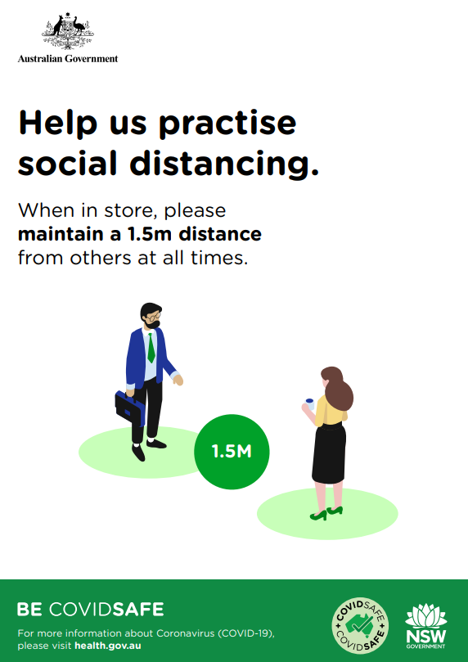

Routine environmental cleaning and disinfection Information

Cleaning is an essential part of disinfection because dirt and grime can inactivate many disinfectants. Cleaning reduces the amount of dirt and so allows the disinfectant to work. Removal of germs such as the virus that causes COVID-19 requires thorough cleaning followed by disinfection.
The length of time the virus that causes COVID-19 can survive on inanimate surfaces varies depending on factors such as the amount of contaminated body fluid (e.g. respiratory droplets) or soiling present, and environmental temperature and humidity.
Coronaviruses can survive on surfaces for many hours or more but are readily inactivated by cleaning and disinfection. It is good practice to routinely clean surfaces as follows:
- Clean frequently touched surfaces with detergent solution (see diagram below).
- Clean general surfaces and fittings when visibly soiled and immediately after any spillage
Routine environmental cleaning requirements can be divided into two groups:
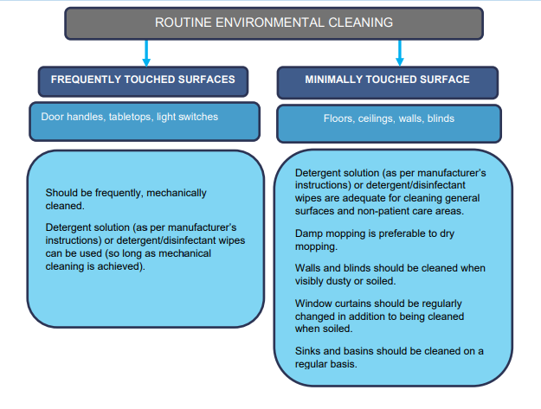
Source: https://health.govcms.gov.au/sites/default/files/documents/2020/05/coronavirus-covid-19-information-about-routine-environmental-cleaning-and-disinfection-in-the-community.pdf

Cleaning Plan
Cleaning Location | Frequency  (include times if applicable) | Who is responsible
(Insert details) | (insert details) | (insert details)

Wellness Poster
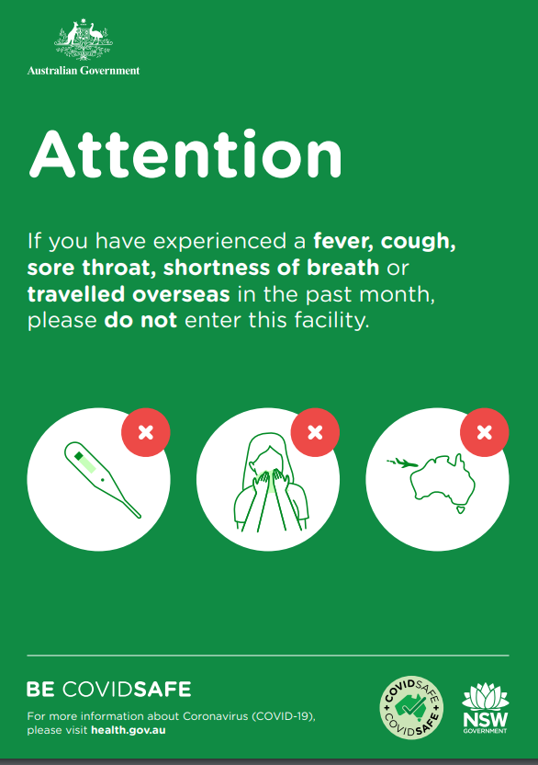

Cleaning Information for you Purchases

Covid Safe Cleaning Information regarding your Purchase
We take care to select quality items for sale in our shop and have implemented our own cleaning processes however, we still recommend that when customers take their purchases home they:
- Wash all clothing, manchester and soft furnishing prior to use
- Cleaning children’s toys with a disinfectant solution
- Wiping down shoes, accessories, handbags, books and homewares with a disinfectant solution
- Wash your hands with soap and water

Bag Packing
