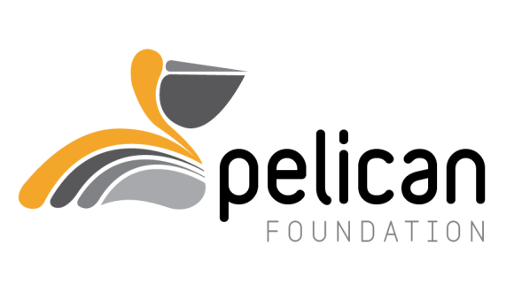
Anglican Diocesan Services
The Pelican Foundation Secretary
GPO Box 1981
Canberra, ACT 2601
p: 02 6245 7101
www.anglicancg.org.au
ABN: 31 478 820 508

Pelican Foundation Grant Application Form - 2022
Please ensure that you have read the Objectives of the Pelican Foundation prior to completion of the Application to ensure that your project falls within the Guidelines of the Pelican Foundation’s Grant Process.
This Pelican Foundation Grant Application Form must be used and submitted electronically.
- Applications Close at 5pm Friday 14th October 2022.
- Acknowledgement of your application will be sent to you by email.
- Assessment of Applications will take place during October/November 2022.
- All Applicants will be notified whether successful or not, in December 2022.
- All Sections of the Pelican Foundation Grant Application Form must be completed.
- Further Documentation may be attached at the end of the Pelican Foundation Grant Application if desired.
- The Declaration must be signed.
- Your Pelican Foundation Grant Application Form must be submitted electronically by 5.00pm Friday 14th October 2022 via email to the Pelican Foundation Board Secretary, Ms Alison Payne.

pelicanfoundation@anglicands.org.au.

APPLICANT DETAILS
1. Full Name of Parish, Group, Diocesan Ministry Unit or Diocesan Organisation:
2. Details of Primary Contact for this application:
Name:
Position:
Phone:
Email:

3. Details of Organisation: (Parish, Group, Ministry Unit, Diocesan Organisation)
Organisation Phone:
Organisation Email:
Organisation Address:

4. Describe the group or organisation seeking funds:

PROJECT DETAILS
1. Title of the Project:
2. Key Aim of the Project:

3. Description of Proposed Project (how it will achieve the aim) : (no more than 200 words)

4. Detailed Project Budget: (You may attach a separate document at the end.)

5. Total Grant and Timeframe Summary
(Preference is given for one-year grants – see Pelican Foundation Objectives)
 | 2023 | 2024 | 2025
Total Cost of Project ($)

Total Grant Applied For ($)

Total Contribution from Applicant/Group/Parish ($)

Please note: Co-contributions are essential

6. Has the project received a Pelican Foundation Grant or any other funding source in the past three years? If so please provide details:

7. Detailed Timeframe for Project (Start & Finish Date), including what steps are being taken to implement the project and achieve the outcomes:

Please comment on each of the following:
1. Who is the target population within the parish/diocese/community?

2. In light of the key Pelican Foundation Objectives, what are the desired outcomes of the project?

3. Will any other groups/organisations be involved? (If so, please name them and how they will be involved)

4. How will you monitor progress? What Key Indicators will be used to evaluate the effectiveness of the project? (Where possible indicators should be specific, measurable and achievable.)

Please attach Annual Parish/Ministry Unit/Organisation Audited Financial Statements.

Has the Parish paid its Parish Contribution? YES NO N/A

Has the latest Annual Parish Return been submitted? YES NO N/A

Has the Parish Council or Agency Board approved this application? YES NO N/A
(Please attach a copy of the resolution)
DECLARATION
(To be signed by the organisation, as specified above)

I (enter full name of signatory) _____________________________________________________

From (enter parish and/or organisation) ______________________________________________

Position Held (enter position/title) ___________________________________________________

Am authorised by the Parish/Ministry Unit/Organisation named in this application to make this application on its behalf.

I confirm that the Parish/Ministry Unit/Organisation is aware of and approves this application to the Pelican Foundation.

I confirm that the Parish/Ministry Unit/Organisation is aware of the Guidelines, Terms and Conditions relating to grants from the Pelican Foundation.

I confirm that all information provided in or attached to this application is true and complete.

I am aware that the Pelican Foundation Board reserves the right to discontinue funding if a project does not meet its objectives and fails to meet its key performance indicators.

Signed for and on behalf of the applicant.

Signature ____________________________________________ Date ___________________

