|  |  |  |  |
| --- | --- | --- | --- |
| (Insert Parish Name)  COVIDSAFE MANAGEMENT PLAN | | | |
| Date | (insert date) | **Version** | (insert version no.) |
| Next review Date: | (insert date) | | |
| CovidSafe plan undertaken by: | (insert names here) | | |
| Responsibility: | (insert name of responsible Parish Rector) | | |

|  |  |
| --- | --- |
| CONTEXT | |
| Context | (insert information - provide an overview of the parish activity. Include details such as:   * Location * Building size * Number of workers (volunteers) * Opening hours * Supervision arrangements * Client or visitor access or outreach * Other?? |
| Scope | This CovidSafe management plan is based on the [Australian Government 3 step Framework for a CovidSafe Australia](https://www.health.gov.au/sites/default/files/documents/2020/05/3-step-framework-for-a-covidsafe-australia-3-step-framework-for-a-covidsafe-australia.pdf) and includes the following essential requirements:   1. Ensure gathering are no larger than current State/Territory requirements 2. Maintain 1.5M distancing and good hygiene and respiratory protocols 3. Stay home if unwell 4. Frequently clean and disinfect communal areas 5. Implementation of this CovidSafe Plan |
| WHS policy statement | (insert site and Parish name) is committed to a healthy and safe workplace. We aim to remove or reduce and manage risks to the health, safety and wellbeing of all workers (clergy, employees, volunteers, and contractors), visitors, and anybody else who may be affected by our ministry activities, and also to ensure all work activities are undertaken in a safe manner*.* |

| **COVIDSAFE PLAN** | | | |
| --- | --- | --- | --- |
| **Critical control point** | **Support material** | **Further information or support material** |
| Workers - Stay at home if unwell policy Workers and visitors are not to visit worksites if they have any cold or flu-like symptoms, have been overseas in the last 14 days or have been in contact with anyone showing signs of Coronavirus eg. fever, dry cough and sore throat.  If the worker has cold or flu like symptoms, they must seek medical advice, get tested for COVID-19 and self isolate. A worker should get tested even if symptoms are mild.  If a worker becomes unwell at work, they are to go home immediately.  Special COVID-19 sick leave is available for employed workers who have exhausted other leave options.  Workers complete a statutory declaration regarding the status of their health prior to starting their shift.  All suspected incidents of COVID-19 are reported.  We make our workers aware of the COVIDSafe app and its benefits to support contact tracing if required. | [Incident report](https://www.isopro.info/Anglicare/Public/pap.aspx?fmid=28)  COVID-19 Health Declaration Form | Good hygiene for coronavirus (COVID 19)  <https://www.health.gov.au/news/health-alerts/novel-coronavirus-2019-ncov-health-alert/how-to-protect-yourself-and-others-from-coronavirus-covid-19/good-hygiene-for-coronavirus-covid-19>  CovidSafe App  <https://www.health.gov.au/resources/apps-and-tools/covidsafe-app#:~:text=The%20app%20helps%20state%20and,if%20you%20are%20at%20risk.> |
| Good hygiene for workers All workers are inducted into our ‘good hygiene’ protocols. This means:   * We wash our hands often with soap and water. This includes before and after eating and after going to the toilet and transitioning between work spaces * We use alcohol-based hand sanitisers when we cannot use soap and water * We avoid touching your eyes, nose and mouth * We clean and disinfect surfaces we use often such as benchtops, desks and doorknobs * We clean and disinfect objects we use often such as mobile phones, keys, wallets etc * We use tap and go instead of cash where possible * We try to increase the amount of fresh air by opening windows or changing air conditioning * We ensure bathrooms are well stocked with hand wash and paper towel. * We follow and ensure social distancing etiquette * We wear PPE where required * We clean our pool cars in between use | ADS Vehicle Operation and Sanitisation | How to handwash poster:  <https://www.who.int/gpsc/5may/How_To_HandWash_Poster.pdf?ua=1>  How to hand rub poster:  <https://www.who.int/gpsc/5may/How_To_HandRub_Poster.pdf>  Simple steps to help stop the spread poster: |
| <https://www.health.gov.au/sites/default/files/documents/2020/03/coronavirus-covid-19-print-ads-simple-steps-to-stop-the-spread-coronavirus-covid-19-print-ads-simple-steps-to-stop-the-spread.pdf> |
| **Good hygiene for clients**  * We ask all clients to ring ahead if they require an appointment * We have installed signage reminding everyone of these requirements and obligations for good general health * We have sanitiser set up in key touch point locations | Wellness poster |  |
| **Social distancing**  Social distancing is one of the best things we can do to stop the spread of coronavirus. Whenever and wherever we can, this protocol will be applied, including:   * Placement of social distancing markers on the floor in areas where clients or workers line up or where workers perform tasks. * Line management continually monitor to ensure everyone is keeping the required distance from each other * Service counters/reception desks set up to support social distancing requirements * Face to face meetings to be replaced with Zoom, phone calls or other approved media options | Social distancing poster | Keeping your distance poster:  <https://www.health.gov.au/sites/default/files/documents/2020/03/coronavirus-covid-19-keeping-your-distance.pdf>  Physical distancing checklist:  <https://www.safeworkaustralia.gov.au/sites/default/files/2020-04/COVID-19-Physical-Distancing-Checklist.pdf> |
| **Cleaning** We recognise that cleaning is an essential part of disinfection because dirt and grime can inactivate many disinfectants. Cleaning reduces the amount of dirt and so allows disinfectant to work. Removal of germs such as the virus that causes COVID-19 requires thorough cleaning followed by disinfection.  As such, our service has developed a cleaning program that has taken into consideration touch point locations and other cleaning needs Refer to our ‘Cleaning Plan’.  In addition, we have:   * reduced objects that may be passed around such as books and collection plates. * put barriers around frequently touched objects of worship, such as shrines, relics or fonts, to prevent people frequently touching these. | Routine environmental cleaning information  Cleaning plan | Retail cleaning:  <https://www.safeworkaustralia.gov.au/covid-19-information-workplaces/cleaning-prevent-spread-covid-19>  Cleaning checklist:  <https://www.safeworkaustralia.gov.au/sites/default/files/2020-04/COVID-19_Cleaning-Checklist.pdf>  Safe Work Australia  <https://www.safeworkaustralia.gov.au/covid-19-information-workplaces/industry-information/general-industry-information/cleaning> |
| **Handling second-hand goods and infection control** According to the World Health Organisation, it is not certain how long the COVID-19 virus can survive on surfaces. Reports and studies are telling us that time can vary from a few hours to several days, depending on the type of surface.  In line with this, we take reasonable precautions by:   * Wearing gloves and masks when required * Only excepting items (clothing, manchester and soft furnishings) that are in good usable condition * Cleaning children’s toys with a disinfectant solution * Wiping down shoes, accessories, handbags, books and homewares with a disinfectant solution * Washing our hands with soap and water or use an alcohol-based sanitiser after handling second-hand goods * Avoiding touching our eyes, mouth and nose   We encourage our customers to also implement infection control procedures with all items that they purchase. At are counter areas we display information to promote this action. | CovidSafe cleaning information for your purchases | NSW Health COVID 19 – Frequently asked questions  <https://www.health.nsw.gov.au/Infectious/covid-19/Pages/frequently-asked-questions.aspx> |
| **Worker/client/ visitor entry and exit protocols** Social distancing considerations are applied when workers/ clients enter and exit our workplace.   * Where possible, separate entry and exit doors are used or entry / exit give way protocols implemented.   + - Sanitiser is made available at all entry/exit points and at the service counters/reception areas |  |  |
| **Number of people inside our building spaces** In line with the new State and Federal restrictions, the number of people inside our workspace will be strictly monitored.  Our worksite is (insert square metres) and is able to accommodate (insert number) of clients (including workers) at any one time.  We display signage to assist adhere to our identified numbers | Calculating the Maximum capacity of your Church with Covid-19 Limits | Physical distancing checklist  <https://www.safeworkaustralia.gov.au/sites/default/files/2020-04/COVID-19-Physical-Distancing-Checklist.pdf> |
| **Money handling** Where possible, we encourage contactless payment and, if handling cash, all workers are diligent about washing their hands and not touching our face. The wearing of disposable gloves is also encouraged along with regular hand washing. |  |  |
| **Vulnerable workers** We acknowledge that some of our workers may be at greater risk of more serious illness with COVID-19 and we undertake measures not to put these people at risk.  These vulnerable workers include:   * Aboriginal and Torres Strait Islander people 50 years and older with one or more chronic medical conditions * People 65 years and older with one or more chronic medical conditions * People 70 years and older * People with compromised immune systems   Where a vulnerable worker is identified, we will risk assess each case and provide options such as re-assigning the workers to roles where they do not need to have contact with others. This may involve the creation of non-customer/client related roles or temporary redeployment. |  | Vulnerable workers:  <https://www.safeworkaustralia.gov.au/covid-19-information-workplaces/industry-information/general-industry-information/vulnerable> |
| **Workers working from home** Where suitable, workers are supported to work from home. To facilitate this arrangement we require:   * All workers are required to complete a working from home assessment and seek approval from their line manager * Our line managers and workers to maintain regular communications, including Sanctuary Meetings and Support and Supervision |  | Poster - Safe Work Australia – How to set up a workstation at home  <https://www.safeworkaustralia.gov.au/sites/default/files/2020-05/Working_from_home_Workstation_Setup_%20Guide-COVID-19.pdf> |
| **Office layout**  To ensure our workspaces are set up appropriately we:   * Design our workspace to allow 4m² per person in any environment * Erect signs at the entrances to lifts and meeting rooms to ensure the maximum safe capacity is not exceeded * Move work stations, desks and tables in staffrooms further apart to comply with social distancing * If possible, roster staff in shifts so less staff are in the workplace at once * Clean and disinfect high touch surfaces, including phones, desks and keyboards regularly * Instruct workers to have meetings by phone or online instead of in person. If not possible, require they meet in a large space and keep meetings short * Encourage and support outdoor walking meetings * Review regular deliveries and request contactless delivery. Check systems for e-invoicing are in place |  |  |
| **Worker amenities** To ensure the amenities for workers managed appropriately we:   * Clean and disinfect high touch surfaces regularly (as per cleaning plan) * Encourage workers to lunch outside rather than in lunch room where possible * Limit the number of workers in these areas as per their size and social distancing capacity |  |  |
| **Providing 1:1 support to clients** To ensure our workers are prepared and have the PPE equipment required to support our clients we:   * Require all face to face workers participate in infection control training * Implement PPE protocols | Examples of the use of Personal Protective Equipment (PPE) |  |
| **Packing bags for customers** To assist with social distancing, wherever possible, customers will be required to pack their own bags | Bag packing poster |  |
| **Incident management**  We understand that where we have staff or volunteers at a location in Australia, it is classified under Work Health and Safety laws as a workplace. Therefore, if anyone within our workplace, whether they be clergy, staff or volunteers, suspects that they may have the virus, or has been exposed to it, the responsible **Parish Rector must be notified** immediately and the incident reported.  Our process for a COVID incident notification is:  1. Notify the responsible line manager immediately  2. Secure the site as outlined on the Safe Work Australia information sheet process  3. Complete an incident report immediately  4. Work with ADS on the appropriate government notification | [Incident report](https://www.isopro.info/Anglicare/public/incidentfull.aspx) | What to do if a worker has COVID 10:  <https://www.safeworkaustralia.gov.au/doc/what-do-if-worker-has-covid-19-infographic#picModal> |
| **Worker wellbeing** We are conscious of the need to monitor the wellbeing of workers during these times and to assist we:   * Maintain regular contact with all workers and provide support and supervision sessions * EAP services are available – Line managers may contact ADS Risk for more details |  |  |
| **Communal meals** We acknowledge that we can no longer share meals and as such, where food is required, our workers, clients and visitors will bring their own supplies in their own containers or wrappers.  The use of disposable tea/coffee cups is used as an option or workers bring their own travel cups and are responsible for washing the item and drying it with paper towel.  For infection control reasons, we do not use tea-towels. |  |  |
| **Monitoring our worksite** To assist in monitoring for areas for improvement we have:   * Nominated a worker or a team of workers to champion safe practices in the workplace and teach their colleagues the proper procedures listed above. Our worksite COVID-19 champion is (insert name) * Created a daily checklist * Report all non-compliances or hazards as they are identified | Checklist reminder  Checklist/Audit template  [Hazard form](https://www.isopro.info/Anglicare/Public/pap.aspx?fmid=27) |  |
| **Attendance register** For the purposes of contact tracing, all workers, clients and visitors are required to provide their names and contact details as well as the date / time of attendance. This information is not to be used for any other purpose and may only be accessed by the responsible officer or their delegate.  The form is designed to be separated into slips that can be individually completed and balloted in a box / container to prevent accessibility by persons other than the responsible officer.  Information on attendance is to be securely retained for a period to enable contact tracing should an incident occur and for no longer than 3 months. | Attendance Register | Diocesan privacy policy |
| **Additional consideration for our high-risk congregation**We have taken into consideration congregants who may be in the high-risk category and as such offer:  * Online services – live stream and recordings * Printed text sermons * Small bible study groups and services * Regular contact via phone and visits * Take measures to ensure drivers of courtesy vehicles minimise close contact with passengers. |  |  |
| **Funerals**We acknowledge that currently the capacity of guests attending a funeral must not exceed 50 guests and have implemented standard social distancing protocols as per the rest of the Plan |  |  |
| **Weddings** We acknowledge that currently the capacity of guests attending a wedding must not exceed 20 guests (excluding the couple, the persons involved in the conducting the service , the photographer and the videographer) and have implemented standard social distancing protocols as per the rest of the Plan |  |  |
| **Singing and music groups** We avoid group singing or chanting and wind instruments (such as flute, oboe or clarinet). Our solo singers maintain at least 3 metres physical distance from other people |  |  |
| **The sharing of meals** |  |  |

Resources

## Stat Dec

**COVID-19 Worker Health Check**

The below must be completed by each worker each time they attend for duty at the worksite.

Note: Flu like symptoms include fever, chills, muscle aches, cough, congestion, runny nose, headaches and fatigue.

|  |  |  |  |  |  |
| --- | --- | --- | --- | --- | --- |
| Date: |  | | Name: |  | |
| I am feeling well | | | No | | Yes |
| I am experiencing cold or flu like symptoms | | | No | | Yes |
| I have been in contact with anyone that is confirmed (or currently being tested) to have COVID-19 | | | No | | Yes |
| Signature: | |  | | | |
| Manager/Supervisor Signature: | |  | | | |

|  |  |  |  |  |  |
| --- | --- | --- | --- | --- | --- |
| Date: |  | | Name: |  | |
| I am feeling well | | | No | | Yes |
| I am experiencing cold or flu like symptoms | | | No | | Yes |
| I have been in contact with anyone that is confirmed (or currently being tested) to have COVID-19 | | | No | | Yes |
| Signature: | |  | | | |
| Manager/Supervisor Signature: | |  | | | |

|  |  |  |  |  |  |
| --- | --- | --- | --- | --- | --- |
| Date: |  | | Name: |  | |
| I am feeling well | | | No | | Yes |
| I am experiencing cold or flu like symptoms | | | No | | Yes |
| I have been in contact with anyone that is confirmed (or currently being tested) to have COVID-19 | | | No | | Yes |
| Signature: | |  | | | |
| Manager/Supervisor Signature: | |  | | | |

|  |  |  |  |  |  |
| --- | --- | --- | --- | --- | --- |
| Date: |  | | Name: |  | |
| I am feeling well | | | No | | Yes |
| I am experiencing cold or flu like symptoms | | | No | | Yes |
| I have been in contact with anyone that is confirmed (or currently being tested) to have COVID-19 | | | No | | Yes |
| Signature: | |  | | | |
| Manager/Supervisor Signature: | |  | | | |

## Social Distancing

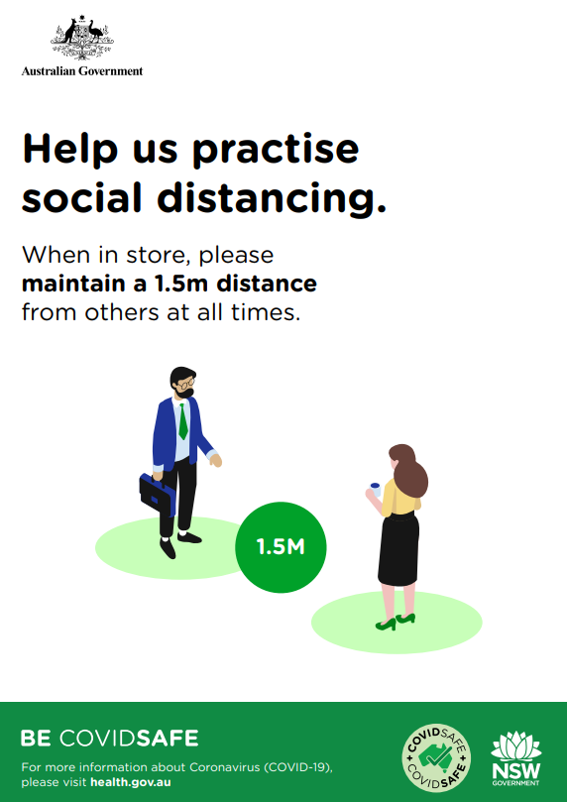

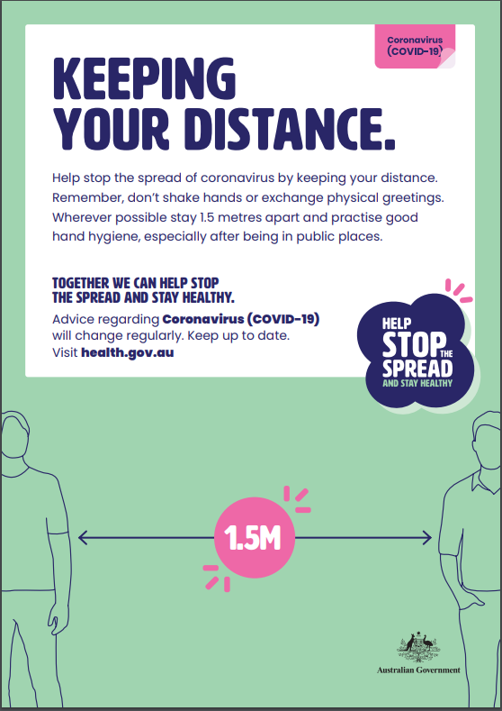

## **Routine environmental cleaning and disinfection Information**

Cleaning is an essential part of disinfection because dirt and grime can inactivate many disinfectants. Cleaning reduces the amount of dirt and so allows the disinfectant to work. Removal of germs such as the virus that causes COVID-19 requires thorough cleaning followed by disinfection.

The length of time the virus that causes COVID-19 can survive on inanimate surfaces varies depending on factors such as the amount of contaminated body fluid (e.g. respiratory droplets) or soiling present, and environmental temperature and humidity.

Coronaviruses can survive on surfaces for many hours or more but are readily inactivated by cleaning and disinfection. It is good practice to routinely clean surfaces as follows:

* Clean frequently touched surfaces with detergent solution (see diagram below).
* Clean general surfaces and fittings when visibly soiled and immediately after any spillage

Routine environmental cleaning requirements can be divided into two groups:

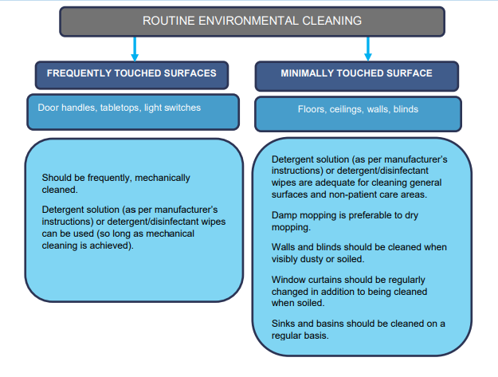

Source: <https://health.govcms.gov.au/sites/default/files/documents/2020/05/coronavirus-covid-19-information-about-routine-environmental-cleaning-and-disinfection-in-the-community.pdf>

## **Cleaning** **Plan**

|  |  |  |
| --- | --- | --- |
| (insert service name) | | |
| Cleaning Location and details | Frequency  (include times if applicable) | Who is responsible |
| (Insert details) | (insert details) | (insert details) |
|  |  |  |
|  |  |  |
|  |  |  |
|  |  |  |
|  |  |  |
|  |  |  |
|  |  |  |
|  |  |  |

Version: (insert number and date)

## Vehicle Operation and Sanitation

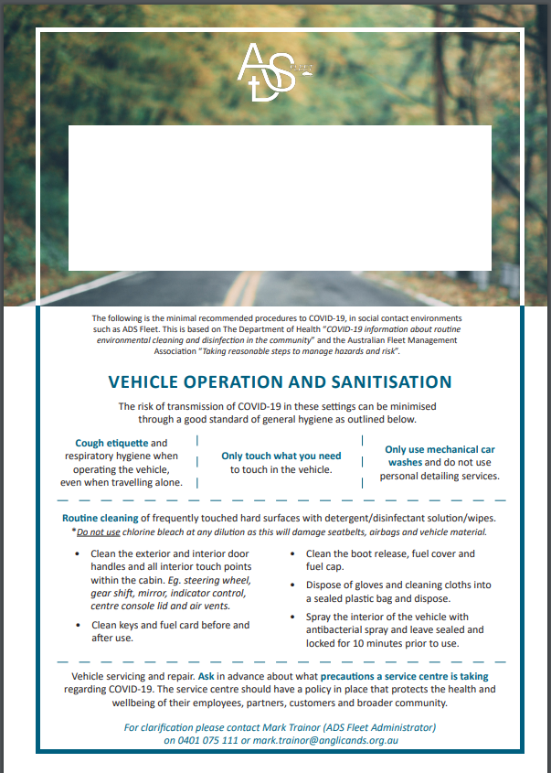

## Wellness Poster

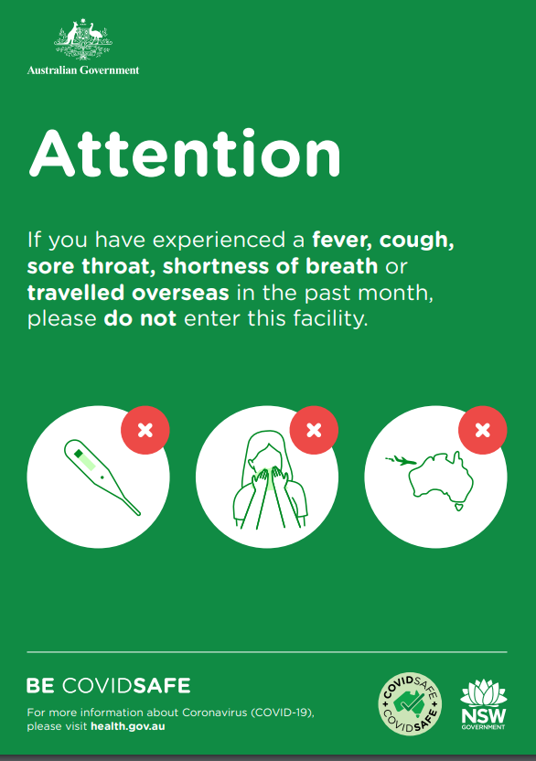

Cleaning Information for you Purchases

## **Covid Safe Cleaning Information regarding your Purchase**

We take care to select quality items for sale in our shop and have implemented our own cleaning processes however, we still recommend that when customers take their purchases home they:

* Wash all clothing, manchester and soft furnishing prior to use
* Cleaning children’s toys with a disinfectant solution
* Wiping down shoes, accessories, handbags, books and homewares with a disinfectant solution
* Wash your hands with soap and water

## PPE face to face client guidelines

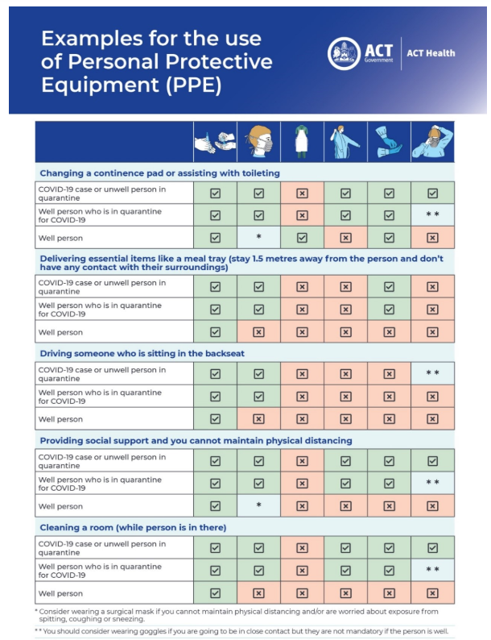

<https://www.covid19.act.gov.au/business-hub/non-government-community-disability-and-health-service-providers#Personal-Protective-Equipment-PPE->

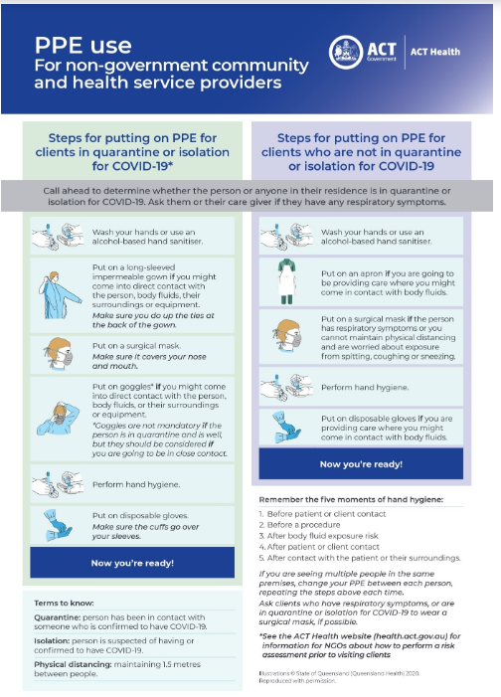

<https://www.covid19.act.gov.au/business-hub/non-government-community-disability-and-health-service-providers#Personal-Protective-Equipment-PPE->

## Bag Packing

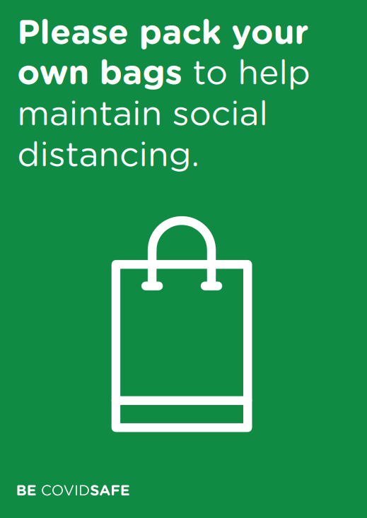

## Checklist Template

|  |  |  |
| --- | --- | --- |
| (Sample) Covid 19 Audit  This checklist is to be complete (insert frequency) | | |
| Date: Time: | | |
| Auditor: | | |
| Audit area | **Pass / Fail** | **Issue Identified/Corrective action** |
| All workers are complete the daily shift statutory declarations regarding their health? | Pass Fail |  |
| All workers are inducted into good hygiene protocols? | Pass Fail |  |
| Where required, workers are using PPE appropriately? | Pass Fail |  |
| Workers are observed practicing good hygiene? | Pass Fail |  |
| Signage is in place at all entry points advising workers and visitors of entry requirements? | Pass Fail |  |
| Clients on site are observed following good hygiene directions? | Pass Fail |  |
| There are adequate stores of PPE including hand sanitiser | Pass Fail |  |
| Workers are observed following social distancing protocols? | Pass Fail |  |
| Cleaning plan has been established? | Pass Fail |  |
| Cleaning plan is being implemented as per directions? | Pass Fail |  |
| Adequate cleaning products are available to carry out plan? | Pass Fail |  |
| Non-contact and social distancing measures are being followed when for all deliveries? | Pass Fail |  |
| A hand sanitiser station is set up at worksite entry points and other frequented touch point locations? | Pass Fail |  |
| The people number limit inside the workspace is being adhered to? | Pass Fail |  |
| Workstations comply with social distancing requirements? | Pass Fail |  |
| Worker amenity protocols are being complied with? | Pass Fail |  |
| Hazards are being reported where identified? | Pass Fail |  |
| Special infection control protocols (ie the handling of second-hand goods) are being followed? | Pass Fail |  |
| Where possible, contactless payment methods are being used? | Pass Fail |  |
| All ‘fail’ or ‘non-compliance’ issues identified have been reported as a hazard? | Pass Fail |  |
| (Other - insert details here) |  |  |
| (Other - insert details here) | Pass Fail |  |
| (Other - insert details here) | Pass Fail |  |
| (Other - insert details here) | Pass Fail |  |
| (Other - insert details here) | Pass Fail |  |
|  |  |  |
|  |  |  |
|  |  |  |
|  |  |  |
|  |  |  |
|  |  |  |
|  |  |  |
|  |  |  |
|  |  |  |
|  |  |  |
|  |  |  |

## Attendance Record

|  |  |
| --- | --- |
| Date: |  |
| Name: |  |
| Address: |  |
| Contact Number |  |

|  |  |
| --- | --- |
| Date: |  |
| Name: |  |
| Address: |  |
| Contact Number |  |

|  |  |
| --- | --- |
| Date: |  |
| Name: |  |
| Address: |  |
| Contact Number |  |

|  |  |
| --- | --- |
| Date: |  |
| Name: |  |
| Address: |  |
| Contact Number |  |

|  |  |
| --- | --- |
| Date: |  |
| Name: |  |
| Address: |  |
| Contact Number |  |

|  |  |
| --- | --- |
| Date: |  |
| Name: |  |
| Address: |  |
| Contact Number |  |

## **Calculating the Maximum capacity of your Church with Covid-19 Limits.**

We are all yearning to be able to gather together again for congregational worship. The announcement that religious gathering of up to 100 will be permitted under step 3 has encouraged many to hope that we can soon resume public congregational gatherings (albeit limited to 100 people). Sadly, however, this will not be the case for many, because our churches are simply not large enough to comply with the physical distancing rules that will still be in effect.

The NSW Government has not yet released the details on the Public Order rules that will apply when we get to step 3, so the analysis below is based on the assumption that religious gatherings during step 3 will need both 4m2 per person and 1.5m physical distancing. These assumptions are based on the data currently available, including the following.

* 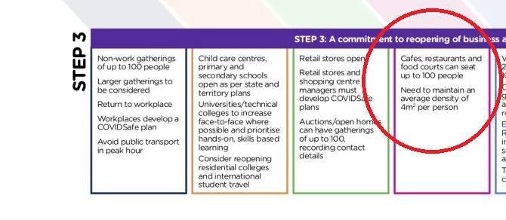Step 3 in the Government’s framework shows that the 4m2 rule will continue to apply for gatherings of up to 100 in cafés and restaurants. Although the framework does not say anything either way about religious gatherings, it is reasonable to assume that the same rule will apply, because of the same risk factors (people seated in proximity for an hour or more).
* The 4m2 rule comes from clause 8 from the *[Public Health (COVID-19 Restrictions on](https://www.legislation.nsw.gov.au/_emergency/Public%20Health%20(COVID-19%20Restrictions%20on%20Gathering%20and%20Movement)%20Order%202020.pdf)*

*[Gathering and Movement) Order](https://www.legislation.nsw.gov.au/_emergency/Public%20Health%20(COVID-19%20Restrictions%20on%20Gathering%20and%20Movement)%20Order%202020.pdf)* 2020. The [NSW Government webpage](https://www.nsw.gov.au/covid-19/what-you-can-and-cant-do-under-rules/four-square-metre-rule) that explains what you can and can’t do under the 4m2 rule says that the rule applies to “**people gathering in the same, undivided indoor space**.” Therefore, it is not legitimate to include the total footprint of your building (crèche, adjacent hall, chancel, kitchen etc) in the floor space calculation. For most churches, the floor space for the calculation should be limited to the nave only (which includes the aisles).

* A place of public worship is [defined](https://www.legislation.nsw.gov.au/_emergency/Public%20Health%20(COVID-19%20Restrictions%20on%20Gathering%20and%20Movement)%20Order%202020_as%20at%209%20May%202020.pdf) as

a building or place used for the purpose of religious worship by a congregation or religious group, whether or not the building or place is also used for counselling, social events, instruction or religious training.

* Taking the previous two bullet points together, it means that the church **and** the hall (**and** the carpark outside, if you might be planning to use that as an extra “place” for religious worship!) all count as a single place of worship, and the maximum allowable for a religious gathering anywhere on the property is 100 people onsite, wherever you put them.  
    
  But it also means that it would be legitimate to have (for example) 50 people in the church and 30 people in the hall, up to the maximum of 100 people onsite at any one time.
* 100 people means 100 individuals - children are included in this count. While family units can sit within the 1.5m physical distancing, each person in the family unit needs to be allocated 4m2.

The following diagrams show the implications of this principles for church capacity. As a rule of thumb, the COVID-19 maximum capacity of your church will be between 20 and 25% of your normal maximum capacity. Consider a hypothetic church with a nave (I,e,, where the congregation sits) with dimensions 20m x10m.

🚹🚹🚹🚹🚹

🚹

🚹

🚹

🚹

🚹🚹🚹🚹🚹

🚹

🚹

🚹

🚹

🚹🚹🚹🚹🚹

🚹

🚹

🚹

🚹

🚹🚹🚹🚹🚹

🚹

🚹

🚹

🚹

🚹🚹🚹🚹🚹

🚹

🚹

🚹

🚹

🚹🚹🚹🚹🚹

🚹

🚹

🚹

🚹

🚹🚹🚹🚹🚹

🚹

🚹

🚹

🚹

🚹🚹🚹🚹🚹

🚹

🚹

🚹

🚹

🚹🚹🚹🚹🚹

🚹

🚹

🚹

🚹

🚹🚹🚹🚹🚹

🚹

🚹

🚹

🚹

🚹🚹🚹🚹🚹

🚹

🚹

🚹

🚹

🚹🚹🚹🚹🚹

🚹

🚹

🚹

🚹

🚹🚹🚹🚹🚹

🚹

🚹

🚹

🚹

🚹🚹🚹🚹🚹

🚹

🚹

🚹

🚹

🚹🚹🚹🚹🚹

🚹

🚹

🚹

🚹

🚹🚹🚹🚹🚹

🚹

🚹

🚹

🚹

🚹🚹🚹🚹🚹

🚹

🚹

🚹

🚹

🚹🚹🚹🚹🚹

🚹

🚹

🚹

🚹

🚹🚹🚹🚹🚹

🚹

🚹

🚹

🚹

🚹🚹🚹🚹🚹

🚹

🚹

🚹

🚹

🚹🚹🚹🚹🚹

🚹

🚹

🚹

🚹

🚹🚹🚹🚹🚹

🚹

🚹

🚹

🚹

🚹🚹🚹🚹🚹

🚹

🚹

🚹

🚹

🚹🚹🚹🚹🚹

🚹

🚹

🚹

🚹

🚹🚹🚹🚹🚹

🚹

🚹

🚹

🚹

🚹🚹🚹🚹🚹

🚹

🚹

🚹

🚹

🚹🚹🚹🚹🚹

🚹

🚹

🚹

🚹

🚹🚹🚹🚹🚹

🚹

🚹

🚹

🚹

🚹🚹🚹🚹🚹

🚹

🚹

🚹

🚹

🚹🚹🚹🚹🚹

🚹

🚹

🚹

🚹

🚹🚹🚹🚹🚹

🚹

🚹

🚹

🚹

🚹🚹🚹🚹🚹

🚹

🚹

🚹

🚹

🚹🚹🚹🚹🚹

🚹

🚹

🚹

🚹

🚹🚹🚹🚹🚹

🚹

🚹

🚹

🚹

🚹🚹🚹🚹🚹

🚹

🚹

🚹

🚹

🚹🚹🚹🚹🚹

🚹

🚹

🚹

🚹

🚹🚹🚹🚹🚹

🚹

🚹

🚹

🚹

🚹🚹🚹🚹🚹

🚹

🚹

🚹

🚹

🚹🚹🚹🚹🚹

🚹

🚹

🚹

🚹

🚹🚹🚹🚹🚹

🚹

🚹

🚹

🚹

🚹🚹🚹🚹🚹

🚹

🚹

🚹

🚹

This space has a floor space of 200 m2, and a normal maximum capacity of 210 people

(21 rows x 10 people per row)

Under COVID-19 restrictions, the theoretical maximum in now only 50 people (@4 m2 = 200 m2).

🚹

2mx2m

🚹

2mx2m

🚹

2mx2m

🚹

2mx2m

🚹

2mx2m

🚹

2mx2m

🚹

2mx2m

🚹

2mx2m

🚹

2mx2m

🚹

2mx2m

🚹

2mx2m

🚹

2mx2m

🚹

2mx2m

🚹

2mx2m

🚹

2mx2m

🚹

2mx2m

🚹

2mx2m

🚹

2mx2m

🚹

2mx2m

🚹

2mx2m

🚹

2mx2m

🚹

2mx2m

🚹

2mx2m

🚹

2mx2m

🚹

2mx2m

🚹

2mx2m

🚹

2mx2m

🚹

2mx2m

🚹

2mx2m

🚹

2mx2m

🚹

2mx2m

🚹

2mx2m

🚹

2mx2m

🚹

2mx2m

🚹

2mx2m

🚹

2mx2m

🚹

2mx2m

🚹

2mx2m

🚹

2mx2m

🚹

2mx2m

🚹

2mx2m

🚹

2mx2m

🚹

2mx2m

🚹

2mx2m

🚹

2mx2m

🚹

2mx2m

🚹

2mx2m

🚹

2mx2m

🚹

2mx2m

🚹

2mx2m

This new maximum capacity is 23.8% (50/210) of the normal maximum capacity.

However, this configuration is only be possible without the pews, and without the constraints imposed by the centre aisle and side aisles.

Taking these into account, the actual maximum (given 4m2, 1.5m distancing and the constraints of pews etc.) will be a bit less. For this hypothetical church (which happened to have convenient dimensions for fitting tessellated regular hexagons), the best configuration that can be achieved is 48 people, assigning each to a Regular hexagon with area 4m2.

🚹

🚹

🚹

🚹

🚹

🚹

🚹

🚹

🚹

🚹

🚹

🚹

🚹

🚹

🚹

🚹

🚹

🚹

🚹

🚹

🚹

🚹

🚹

🚹

🚹

🚹

🚹

🚹

🚹

🚹

🚹

🚹

🚹

🚹

🚹

🚹

🚹

🚹

🚹

🚹

🚹

🚹

🚹

🚹

🚹

🚹

🚹

🚹

🚹

🚹

🚹

🚹

🚹

🚹

🚹

🚹

🚹

🚹

🚹

🚹

🚹

🚹

🚹

🚹

🚹

🚹

🚹

🚹

🚹

🚹

🚹

🚹

🚹

🚹

🚹

🚹

🚹

🚹

🚹

🚹

🚹

🚹

🚹

🚹

🚹

🚹

🚹

🚹

🚹

🚹

🚹

🚹

🚹

🚹

🚹

🚹

🚹

🚹

🚹

🚹

🚹

🚹

🚹

🚹

🚹

🚹

🚹

🚹

🚹

🚹

🚹

🚹

🚹

🚹

🚹

🚹

🚹

🚹

🚹

🚹

🚹

🚹

🚹

🚹

🚹

🚹

🚹

🚹

🚹

🚹

🚹

🚹

🚹

🚹

🚹

🚹

🚹

🚹

🚹

🚹

🚹

🚹

🚹

🚹

🚹

🚹

🚹

🚹

🚹

🚹

🚹

🚹

🚹

🚹

🚹

🚹

🚹

🚹

🚹

🚹

🚹

🚹

🚹

🚹

🚹

🚹

🚹

🚹

🚹

🚹

🚹

🚹

🚹

🚹

🚹

🚹

🚹

🚹

🚹

🚹

🚹

🚹

🚹

🚹

🚹

🚹

🚹

🚹

🚹

🚹

🚹

🚹

🚹

🚹

🚹

🚹

🚹

🚹

🚹

🚹

🚹

🚹

🚹

🚹

🚹

🚹

🚹

🚹

🚹

🚹

🚹

🚹

🚹

🚹

🚹

🚹

In the case of this hypothetical church, the covid-19 maximum capacity is 22.8% (48 / 210 ) of its former maximum capacity.

**Summary points**

* As a quick estimate of your COVID-19 capacity, use 22% of your current maximum capacity.
* The 4m2 is the key limiting factor in this calculations. If the only rule was to maintain physical distancing at 1.5m, this could he achieved if everyone was allocated a hexagon with side length of 90cm, i.e., area = 2.1m2). This almost doubles the capacity of the church, and if family units can sit within 1.5m of each other, there is even greater capacity.
* The 100 person limit applies to the church site as a whole as a place of public worship. You cannot have two gatherings of 70 people (70 in the church, 70 in the hall) on site at the same time.
* Fixed pews will impede your maximal capacity. Pews are typically 92-95 cm apart. Thus in order to maintain 1.5 physical distancing, you will need to leave every other pew empty. You will also need to indicate on the valid pews the spot where people may sit (eg. red dots placed at 1.5m intervals). The length of your pew will be the limiting factor here. For example, a 4.4m pew can only hold two people, even though normally it could hold 5 (or 6 people if you pack them in).

**Rt Rev Dr Michael Stead** Bishop of South Sydney 14 May 2020

## Checklist reminder

