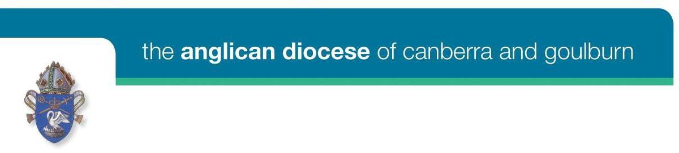

SUBSIDIES AVAILABLE FOR PROFESSIONAL SUPERVISION 2024
Following General Synod’s ratification of the Ministry Wellbeing and Development Policy in 2022, Clergy across the Anglican Church of Australia will be required to engage in professional supervision with a qualified supervisor.
POLICY (Ministry Wellbeing and Development Document)
4.1 Ministers must complete a minimum of six hours of individual professional supervision or twelve hours of group professional supervision each calendar year.
4.4 Dioceses have discretion to allow reduced hours of professional supervision in the case of a minister……having reduced working hours (i.e., part-time)
In addition, the Anglican Diocese of Canberra and Goulburn is committed to:
- supporting honorary deacons and priests (who are licensed) with significant parish ministries
- supporting lay ministers, both stipendiary and non-stipendiary, in charge of parishes or ministry units

In order to assist clergy and lay ministers to engage with the required professional supervision, subsidies will be offered as follows:

Stipendiary clergy in parishes and ministry units
  - Ministry units with stipendiary clergy who are paid four or more days per week are asked to include the cost of a minimum of six professional supervision sessions per year in their budget and to meet this cost for their clergy.
  - If a ministry unit is unable to meet this cost, special application can be made to the ADS for assistance.
  - Ministry units with stipendiary clergy who are paid less than four days a week can claim back from the ADS the cost of four professional supervision sessions per year.

Stipendiary lay ministers in parishes and ministry units
  - Ministry units with stipendiary lay ministers who are paid four or more days per week are asked to include the cost of a minimum of six professional supervision sessions per year in their budget and to meet this cost for their lay ministers.
  - If a ministry unit is unable to meet this cost, special application can be made to the ADS for assistance.
  - Ministry units with stipendiary lay ministers who are paid less than four days a week can claim back from the ADS the cost of four professional supervision sessions per year.

Clergy in school, hospital or correctional centre chaplaincy
  - Where a school, hospital or correctional centre will not fund professional supervision, clergy can claim back from the ADS cost of six professional supervision sessions per year if working four or more days a week, or four professional supervision sessions per year if working less than four days a week.

Honorary priests and deacons licensed to parishes and ministry units

Honorary Clergy are not required to undertake professional supervision. However, those with significant ministries in their parish would benefit from such supervision.

Ministry units with honorary clergy who work the equivalent of four or more days per week are asked to include the cost of a minimum of six professional supervision sessions per year in their budget and to meet this cost for their honorary clergy.

If a ministry unit is unable to meet this cost, special application can be made to the ADS for assistance.

Ministry units with honorary clergy who work the equivalent of less than four days a week can claim back from the ADS the cost of four professional supervision sessions per year.

Licensed non-stipendiary lay ministers with responsibility for parishes or ministry units
  - Parishes with licensed non-stipendiary lay ministers in charge of the parish or ministry units can claim back from the ADS the cost of six professional supervision sessions per year for lay ministers working four or more days a week, or four professional supervision sessions per year for lay ministers working less than four days a week.

- Clergy with an ATO
Unfortunately, the diocese needs to prioritise available funding for licensed clergy and cannot subsidise professional supervision for clergy with an ATO.

In order to claim for supervision costs, clergy & lay ministers must undertake a minimum of four supervision sessions per year.
Forms to apply for special assistance, or to claim back professional supervision costs will be available soon on the website.

