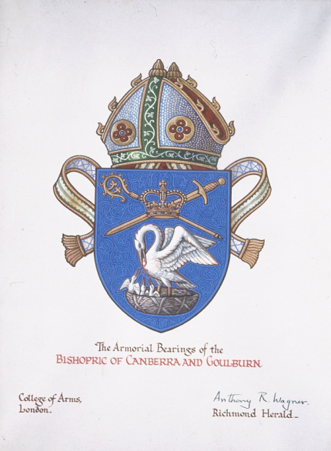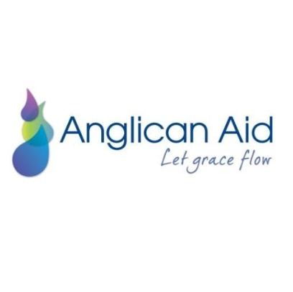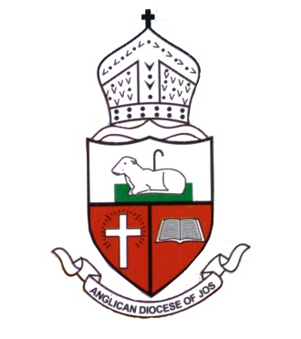

**Jos Jottings, December 2022**

**Advent Tears, yet Advent Blessings!**

We weep with and pray for Christian village communities in northeast Nigeria continuing to suffer this Advent. On 30 November, the Morning Star News Agency reported that in November alone, attacks in Plateau and Kaduna states by suspected Fulani herdsmen and others have left at least 40 Christian men, women and children dead, many more injured and dispossessed, and villages and belongings looted and burned.

**In** **Plateau State**’s Bokkos Local Government Area, south of Jos, hundreds of suspected Fulani herdsmen and others reportedly attacked predominantly Christian villages:

* at 10pm on 23 November, in reportedly the third attack in a week on Ser village, hundreds of assailants left 9 Christians dead, 20 injured and 30 houses burned down;
* at about 10pm on 22 November, about 200 herdsmen attacked Wumat village in the same county, killing 11 Christians, burning down dozens of houses, and shooting at fleeing Christians. The attackers, armed with guns and machetes, were communicating with each other in the Fulani language; and,
* on 16-17 November, more than 300 Fulani herdsmen reportedly attacked Maikatako village and Dadin Kowa, killing 11 Christians and burning down a church and more than 20 houses, according to Solomon Maren, a Nigerian National Assembly parliamentarian representing the Bokkos area. “Within a month, we have buried more than 30 Christians killed by the herdsmen,” Maren said. “These victims include women and children.”

Underscoring the horror of this, Maikatako area resident Sule Marshall identified some of those slain in the Maikatako attack as Seth Matthew (2); Peret Satmak (13); Longkinan Satmak (1); Taho Isa (7); Umundum Maren (82); Satmun Gyokos (27); Larai Ginai (70); Dorcas Satmak (28); Nanribet Satmak; Sakanjalla Isa; and Ubwas Emmanuel.

A representative of the Emancipation Centre for Crisis Victims in Nigeria said that from 10-16 November, the herdsmen and other terrorists also attacked the predominantly Christian villages of Kunet, Maiyanga, Maijankai, Folloh and Sangwak.

**In Kaduna State** (bordering on Plateau state), suspected Fulani herdsmen and other terrorists killed 10 Christians and kidnapped nine others, including a Roman Catholic priest, in the past three weeks, area residents said. In Kajuru Local Government Area, the assailants reportedly attacked the villages of Cibiya, Karamai, Gefe and Tudun Mare, killing six Christians.

In Kachia Local Government Area, 9 Christians were kidnapped on 8 November, including a Catholic priest, the Rev. Abraham Kunat, from Idon Gida village.

According to his brother Kefas Ibrahim, Christian telecommunications worker, Obadiah Ibrahim, who was abducted at Sabon Gaya on the Kaduna-Abuja Highway in October was tortured and killed by kidnappers on 17 November after they had received a ransom payment of 3 million naira (US$6,755) for his release. The kidnappers have since demanded a ransom for the return of his body.

Numbering in the millions across Nigeria and the Sahel, predominantly Muslim Fulani comprise hundreds of clans, many of whom do not hold extremist views. However, as noted in the recent report of the United Kingdom’s All-Party Parliamentary Group for International Freedom or Belief (APPG), some Fulani do adhere to radical Islamist ideology. “They adopt a comparable strategy to Boko Haram and ISWAP [Islamic State West Africa Province] and demonstrate a clear intent to target Christians and potent symbols of Christian identity,” the APPG report states. Christian leaders in Nigeria have said they believe herdsmen attacks on Christian communities in Nigeria’s Middle Belt are inspired by their desire to forcefully take over Christians’ lands and impose Islamic rule, parallel with the desertification that has made it more difficult for the Fulani to sustain their herds and lifestyle.

At the same time, we rejoice with our partners in Jos Diocese, who have been greatly blessed by confirmation of healing for Bishop Ben, concluding chemotherapy after successful cancer surgery, and by an inspiring Bishop’s charge to the diocesan Synod in November. As Bishop Ben said on 9 November, after his treating oncologist paid tribute to God’s healing hand on Ben, “Glory to God! Cancer-free yet again!”. Ben’s Bishop’s Charge to Synod, live-streamed from the United States as his treatment wraps up, can be viewed at <https://www.facebook.com/AnglicanDioceseOfJos/videos/862916141398900> .

**For prayer**:

* Praise God for his healing of Bishop Ben Kwashi, and pray for strength for Ben as he resumes his diocesan and international ministry duties.
* Pray fervently for protection of our Christian sisters and brothers in Jos Diocese and northeast Nigeria from violence and persecution, especially as they gather to celebrate Christmas, and an end to this violence. Pray for those grieving the loss of loved ones and possessions this Christmas.
* Pray for Jesus to continue to raise up church leaders like Bishop Ben who will have the courage to speak the truth to all, including those in power in Nigeria, and to stand for peace through the power of the gospel.
* Keep praying for a spirit of generosity this Advent season amongst us in Australia to provide practical support under our gospel partnership with brethren in Jos.

To make a tax-deductible donation to projects under our Diocesan partnership to support our persecuted fellow-Christians in Jos and Plateau State in Nigeria, go to <https://anglicanaid.org.au/locations/Nigeria> . To book a presentation on the situation in Nigeria and our partnership with Jos Diocese for your church or fellowship group, contact Rev Canon Patrick Cole on [pandncole@bigpond.com](mailto:pandncole@bigpond.com) .