Correspondence should be addressed to The Secretary,
c/- GPO Box 1981, CANBERRA A.C.T. 2601
ABN 37 590 212 318
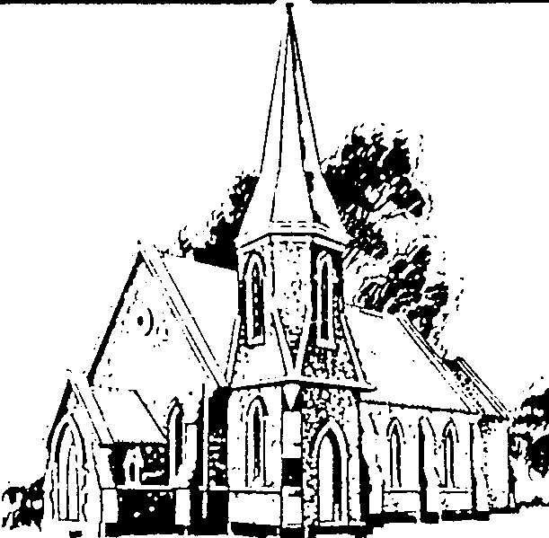

Anglican Historical Society

Diocese of Canberra & Goulburn

APPLICATION FOR MEMBERSHIP

Surname/s (Please use block letters) |  | Given Name |  | Title

Postal Address

Home Address (if different from above)

Telephone (Home) |  | Telephone (Work) |  | Telephone (Mobile)

Email Address (please print)

Parish (optional)

I/We hereby apply for membership of the Anglican Historical Society (Diocese of Canberra & Goulburn) and I/we agree to be bound by the rules of the Society in force at this time.

Signature: |  | Signature: |  | Date:

Type of Membership: (Please indicate the type of membership and number of years chosen)
No. | Tick | Type | 1 Year | 2 Years | 3 Years | Comments
301 |  | Group 1: Individual, Couple or  Family | $25.00 | $45.00 | $60.00
302 |  | Group 2: Pensioner, Retired Individual or Couple, Student | $20.00 | $35.00 | $45.00
303 |  | Group 3: Institution or Parish | $30.00 | $55.00 | $75.00

Please forward this completed form to:
The Secretary, Anglican Historical Society, c/- GPO Box 1981, CANBERRA ACT 2601
Please enclose your cheque or money order, or, you may pay by bank transfer to:
BSB: 702389
Account: 05202514

If you use a bank transfer, please indicate by ticking this box

ANGLICAN HISTORICAL SOCIETY
DIOCESE OF CANBERRA AND GOULBURN

ESTABLISHMENT

The Anglican Historical Society (Diocese of Canberra and Goulburn) was established in 1985.

AIMS AND OBJECTIVES
1.To promote the study and appreciation of the history of the diocese and its parishes and to set this history within the context of the religious history of Australia.

2.To appreciate stories of faith at specific times and places in the history of the Diocese.

3.To encourage the preservation of records and other material.

4.To promote the publication of papers.

5.To visit places of historic interest.

6. To financially support as determined and as funds are available the above aims.

PUBLICATIONS AND DATABASES

A Journal is published in April and October each year. The cost of the Journal is included in the annual membership subscription.

Newsletters advise members of activities and provide membership updates.

The Society supports the publication of books relating to the history of the diocese.

Parish, Clergy and Churches Databases are maintained covering all parishes, clergy and churches in the diocese from 1838.

A digital archive of photographs of historic interest is being established.

There is an ongoing project to list the location of stored parish records and to encourage the appropriate storage of parish records, photographs and other material.

LECTURES, ANNUAL CHURCH SERVICE AND EXCURSIONS

The Society holds an annual autumn lecture with topics relating to the religious history of Australia.

A Service of Choral Evensong is held each September.

There are two field trips a year – a day trip for the Annual General Meeting in April/May, and a weekend excursion in October. The programmes include visits to churches and historic sites. Additional excursions are arranged to coincide with special events in the tri-diocesan region.

FURTHER INFORMATION

For further information please contact Ann Skamp, Secretary, Anglican Historical Society, c/- GPO Box 1981, CANBERRA ACT 2610. email: annskamp@aapt.net.au or Robyn Body, Membership Officer, 34 Yarra Street, KALEEN ACT 2617, tel: (02) 6241 4948, email: crb34@bigpond.com .

