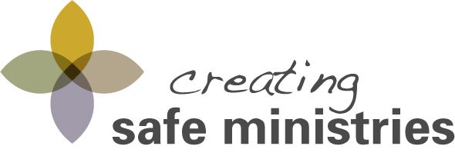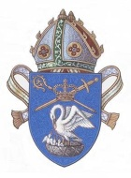
Creating Safe Ministries Workshop Registration Form
Parish/Church Name of Participant/s
Parish/Church email address
Church address where certificates/invoice will be posted
WORKSHOP DETAILS
Please cross → |  |  | Awareness |  |  |  |  | Refresher
Workshop date:
Host Church:
PARTICIPANT’S DETAILS
First name | Surname |  |  | Ministry Activity |  |  | Email address |  | Phone Number
Please complete the CSM workshop Registration Form and email to Gaynor Elder at gaynor.elder@anglicands.org.au at least 10 days before a workshop date.

