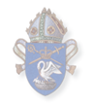

Special Religious Education Training Record

Personal Record of _______________________________

Please fill in and keep for your own records

Working with Children Check Number and Expiry

WWCC # ________________________

Date of Birth ____________________ DoB is used for verification of WWCC

Expiry ________________________
This needs to be renewed every five years

Creating Safe Communities Workshop

Completed Creating Safe Communities workshop or another workshop from a member church of Safe Church Training Agreement (SCTA).

Date Completed ___________________

Venue ___________________________________________
This needs renewing every three years

SRE Authorisation Card

Card Issued by ______________________________________

Expires ___________________________
This card requires an annual renewal.
Initial SRE Training
(based on the agreed ICCOREIS Framework)

Module 1: Teaching SRE in Government Schools

Exploring ways of doing SRE that schools and parents are likely to appreciate, while teaching a strong biblical message.

E.G. Watch GodSpace/Baptist SRE Initial Training DVD & completed worksheet.

Date ________________

Module 2: Learning and Teaching

How do children (and adults) learn and what ways do we teach? This module looks at communication and particularly ways to communicate effectively with kids. It looks at elements of Good Communication, What’s Different about Communicating with Kids? SRE Appropriate Language, Messages that are Shaping Kids, Different Teaching Styles.

E.G. Watch GodSpace/Baptist SRE Initial Training DVD & completed worksheet
‘MeToo’ Module Two and Five.

Date ________________

Module 3: Preparing and Delivering Lessons

Focusing on what we teach, the curriculum, kid’s and our God view, preparing and delivering lessons and exploring on-going learning and support for teachers.

E.G. Watch GodSpace/Baptist SRE Initial Training DVD & completed worksheet
‘MeToo’ Module Six.

Date ________________
Module 4: Communicating in the Classroom

Looking at relating well to contemporary kids, group management and strategies that help kids learn.

E.G. Watch GodSpace/Baptist SRE Initial Training DVD & completed worksheet or
‘MeToo’ Module Six.

Date ________________

Module 5: Introduction to the Bible/SRE & the Bible

An interactive Bible overview to help teachers have a good understanding of the development of the Bible, when/where people and events fit into God’s Story for us all. As well as ensuring that what and how we teach the Bible is relevant for today’s kids and youth.

E.G. Watch GodSpace/Baptist SRE Initial Training DVD & completed worksheet or
‘MeToo’ Module One and Three or The Bible Overview.

Date ________________

Module Six: Observation in the Classroom

Module six is an observation lesson where you are observed by someone you feel you can learn from (i.e. another SRE teacher, coordinator or rector). For those who are in remote areas and not able to have such a person observe, there is a form that you may give the classroom teacher to fill out. Please ask the permission of the principal first. Both templates are available from http://baptistsre.nswactbaptists.org.au/Baptist_SRE/Important_Forms.html

We encourage you to observe someone else too. Peer learning is a wonderful experience.

Some Helpful Resources
https://www.godspace.org.au/home.html

http://cepconnect.com.au/curriculum

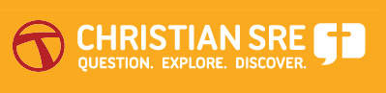

http://training.christiansre.com.au/login/index.php

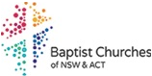

http://baptistsre.nswactbaptists.org.au/Baptist_SRE/Training.html

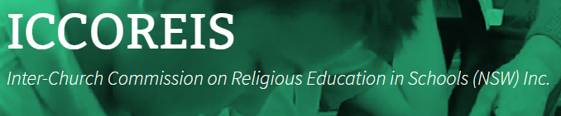

http://www.iccoreis.asn.au/

